The TV Shield Outdoor Speaker & Amp Kit Installation Instructions
Below are the step by step instructions of how to easily hook up your kit for most televisions. Each TV design may be different, so please also refer to your television instructions for running “external speakers.”
If you have already installed your TV into The TV Shield It may be necessary to uninstall your TV from The TV Shield to install the RCA cable.
Included Items: (1) RCA Cable (2) Speaker Wire (2) Velcro Coins (1) Amp (1) Power Cord (2) Speakers
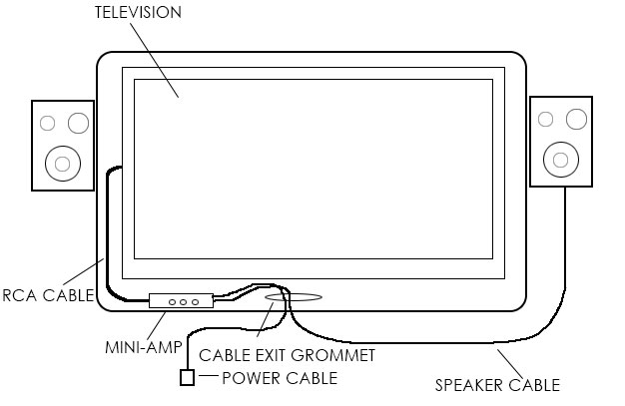
- Take your RCA cable and connect to the back of the television audio output (prior to installing your television into The TV Shield). There may be two outputs on your TV. Please reference your manual to see which one will allow volume control via your TV remote. Some televisions may not have this feature.
- Attach the mini-amp inside the The TV Shield via the Velcro coins. Be sure to thoroughly clean The TV Shield with alcohol or dish soap to remove any grease to allow the Velcro adhesive backing to properly adhere to The TV Shield. You may also install the mini-amp outside The TV via The TV Shield receiver cabinet. Now plug the RCA Cable into the back of the mini-amp.
- Run power cord from power source to mini-amp.
- Mount the Speakers to the outside of The TV Shield or to wall or ceiling or other area that you prefer.
- Run speaker wire from mini-amp to speaker.
- Test audio volume and levels so they do not distort and play loud enough to your liking. Also test that your volume is controllable via the television’s volume control. This may be a feature only available on certain televisions please refer to manual.
- Enjoy your new indoor/outdoor speaker set.

*This mini amp also has a MP3 input that will give you the ability to use any MP3 player device so you can enjoy your music in your new indoor/outdoor space.

